ONEWAY CRT BY Gender1
/STATISTICS DESCRIPTIVES HOMOGENEITY WELCH
/PLOT MEANS
/MISSING ANALYSIS.

Oneway

Notes
Output Created |  | 05-May-2019 23:00:18
Comments
Input | Active Dataset | DataSet0
Input | Filter | <none>
Input | Weight | <none>
Input | Split File | <none>
Input | N of Rows in Working Data File | 30
Missing Value Handling | Definition of Missing | User-defined missing values are treated as missing.
Missing Value Handling | Cases Used | Statistics for each analysis are based on cases with no missing data for any variable in the analysis.
Syntax |  | ONEWAY CRT BY Gender1  /STATISTICS DESCRIPTIVES HOMOGENEITY WELCH  /PLOT MEANS  /MISSING ANALYSIS.
Resources | Processor Time | 00 00:00:00.984
Resources | Elapsed Time | 00 00:00:00.989

[DataSet0]

Descriptives
 | N | Mean | Std. Deviation | Std. Error | 95% Confidence Interval for Mean
 |  |  |  |  | Lower Bound | Upper Bound
Female | 6 | 6.3667 | 2.14072 | .87394 | 4.1201 | 8.6132
Male | 24 | 9.2042 | 3.35345 | .68452 | 7.7881 | 10.6202
Total | 30 | 8.6367 | 3.32291 | .60668 | 7.3959 | 9.8775

Descriptives
 | Minimum | Maximum
Female | 4.00 | 9.20
Male | 3.20 | 14.00
Total | 3.20 | 14.00

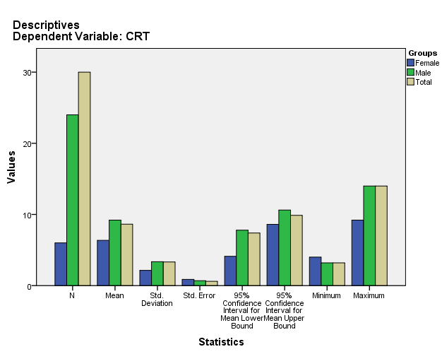

Test of Homogeneity of Variances
CRT
Levene Statistic | df1 | df2 | Sig.
2.180 | 1 | 28 | .151

ANOVA
CRT
 | Sum of Squares | df | Mean Square | F | Sig.
Between Groups | 38.647 | 1 | 38.647 | 3.843 | .060
Within Groups | 281.563 | 28 | 10.056
Total | 320.210 | 29

Robust Tests of Equality of Means
CRT
 | Statisticª | df1 | df2 | Sig.
Welch | 6.533 | 1 | 12.032 | .025
a. Asymptotically F distributed.

Means Plots

